**# Homework4**

流行病學與生物統計計算

Homework 4

學號：b07401048

系級：醫學五

姓名：賴柏瑞

**#Q1 : Calculate factorial(10), using while() and for() respectively**

*# Homework4*

*#Q1 : Calculate factorial(10), using while() and for() respectively*

*# while(){}*

**fa** <- function(x) {

if (x != **round**(x) || x < 0) {

x <- "error, x should be nature number or 0"

}else if (x == 0 || x == 1) {

x <- 1

}else {

i <- x - 1

while (i != 1) {

x <- x * i

i <- i - 1

}

}

return(x)

}

fa(10) *# 10! = 3628800*

*# for(){}*

**fac** <- function(x) {

if (x != **round**(x) || x < 0) {

x <- "error, x should be nature number or 0"

}else if (x == 0 || x == 1) {

x <- 1

}else {

for (i in 1:(x - 1)) {

x <- x * i

}

}

return(x)

}

fac(10) *# 10! = 3628800*

**# Q2 use while(){} and cat() to find missing value**

*# Q2 use while(){} and cat() to find missing value*

**find_na** <- function(x) {

done <- FALSE

i <- 1

while (!done) {

if (**is.na**(x[i] == 1)) {

done <- TRUE

}else if (i == (**length**(x))) {

i <- "NULL"

done <- TRUE

}else {

i <- i + 1

}

}

return(**cat**(i, "\n"))

}

x <- **c**(3600, 5000, 12000, NA, 1000, 2000, 600, 7500, 1800, 9000)

find_na(x)

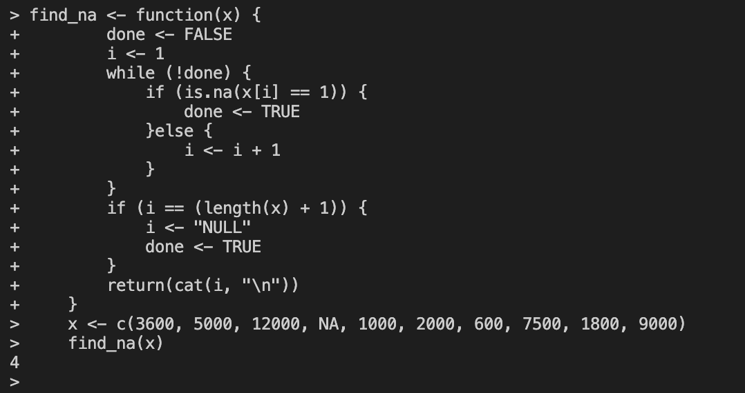**# Q2 terminal**

**# Q3 : BMI curve ID51 - ID60**

*# Q3 : BMI curve ID51 - ID60*

BMI <- **read.csv**("/Users/raymond/Desktop/R/course/data/BMIrepeated.csv")

x <- **seq**(0, 9, by = 3)

y <- **cbind**(BMI$BMI0, BMI$BMI1, BMI$BMI2, BMI$BMI3)

**png**(filename = "hw4.3.png", width = 2000, height = 3000, res = 200)

**par**(mfrow = **c**(1, 2))

**plot**(x, y[1, ], type = "b",

lwd = 1, col = 1, lty = 1, pch = 1,

ylim = **c**(15, 50),

axes = FALSE,

xlab = "month", ylab = "BMI", main = "placebo group")

for (i in 2:10) {

**lines**(x, y[i, ], lty = 1, lwd = 1, col = i, type = "b", pch = i)

}

**axis**(1, at = x, labels = **seq**(0, 9, by = 3))

**axis**(2, at = y)

**legend**("top", bty = "n",

**c**("ID1", "ID2", "ID3", "ID4", "ID5", "ID6", "ID7", "ID8", "ID9", "ID10"),

lty = 1, col = (1:10), lwd = 1, pch = (1:10), cex = 0.8, pt.cex = 1.0)

**plot**(x, y[51, ], type = "b",

lwd = 1, col = 11, lty = 1, pch = 11,

ylim = **c**(15, 50),

axes = FALSE,

xlab = "month", ylab = "BMI", main = "drug group")

for (k in 52:60) {

**lines**(x, y[k, ], lty = 1, lwd = 1, col = k - 40, type = "b", pch = k-40)

}

**axis**(1, at = x, labels = **seq**(0, 9, by = 3))

**axis**(2, at = y)

**legend**("top", bty = "n",

**c**("ID51", "ID52", "ID53", "ID54", "ID55", "ID56", "ID57", "ID58", "ID59", "ID60"),

lty = 1, col = (11:20), lwd = 1, pch = (11:20), cex = 0.8, pt.cex = 1.0)

**dev.off**()

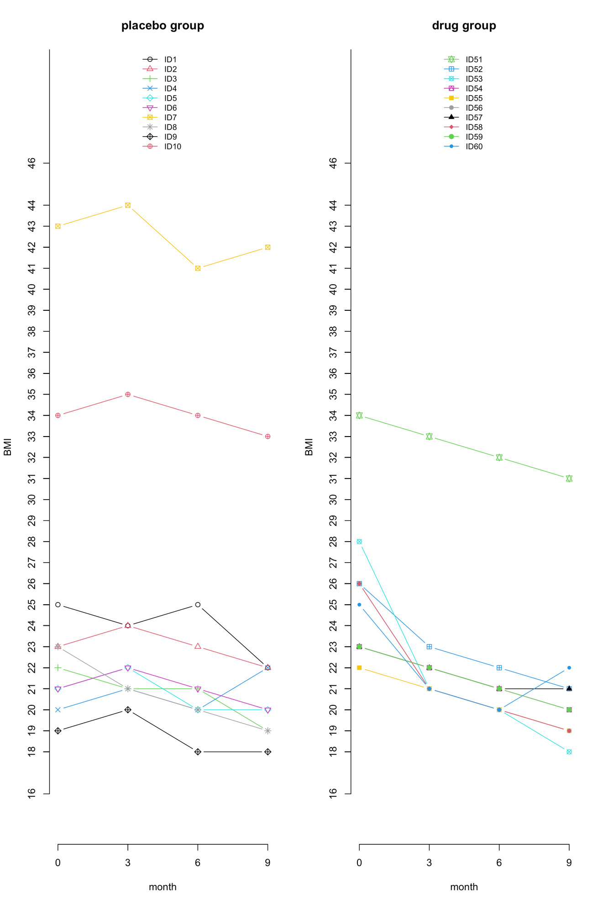

**# Q4: 3D pie chart with percentage**

*# Q4 : 3D PIE with percentage*

**library**(plotrix)

**par**(mfrow = **c**(1, 1))

subject <- **c**(10, 12, 4, 16, 8)

lbls <- **c**("US", "UK", "Australia", "Germany", "France")

percent <- **round**((subject / **sum**(subject)) * 100)

lbls <- **paste**(lbls, percent)

lbls <- **paste**(lbls, "%", sep = "")

**png**(filename = "hw4.4.png", width = 3000, height = 2000, res = 200)

pie3D(subject, labels = lbls, explode = 0.1, col = **rainbow**(**length**(lbls))

, main = "pie chart of countries")

**dev.off**()

